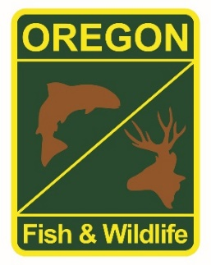

**State Fisheries Genomics Lab Tissue Sample Intake Form**

Please complete the top part of this form and send to: [kathleen.omalley@oregonstate.edu](mailto:kathleen.omalley@oregonstate.edu)

Make arrangements with us prior to dropping off the tissue samples and include a copy of this form with your samples.

**Date of Drop off (Month/Day/Year):**

**Contact Person for samples: Evan Leonetti**

**Phone:** 541-464-2147  **Email:** Evan.Leonetti@odfw.oregon.gov

**Project dropping off samples:** Umpqua Fish District

**Date samples Collected: (Month/Year):** May, June 2021

**Description of samples (e.g. species, collection locations, collection dates, collection methods, number of samples, life stage; may attach spreadsheet):**

See Spreadsheet

All samples are from South Umpqua Falls. 43.054761, -122.686010. Evan realized there is one sample from a hatchery origin fish, but it is labeled in the datasheet.

**If applicable, known origin (e.g. natural or hatchery):** all non- fin-clipped or indicated on form

**Sample type (e.g. fin tissue, scale, muscle, etc):** most are opercle “punches” some fin clips

**Storage method (e.g. dry, 95% ethanol, RNA later, etc):** 95% Ethanol.